Final Project Submission
Lance Tran
CS 330
April 25, 2026

Introduction
The following image is the reference image that I had used in order to make my scene. 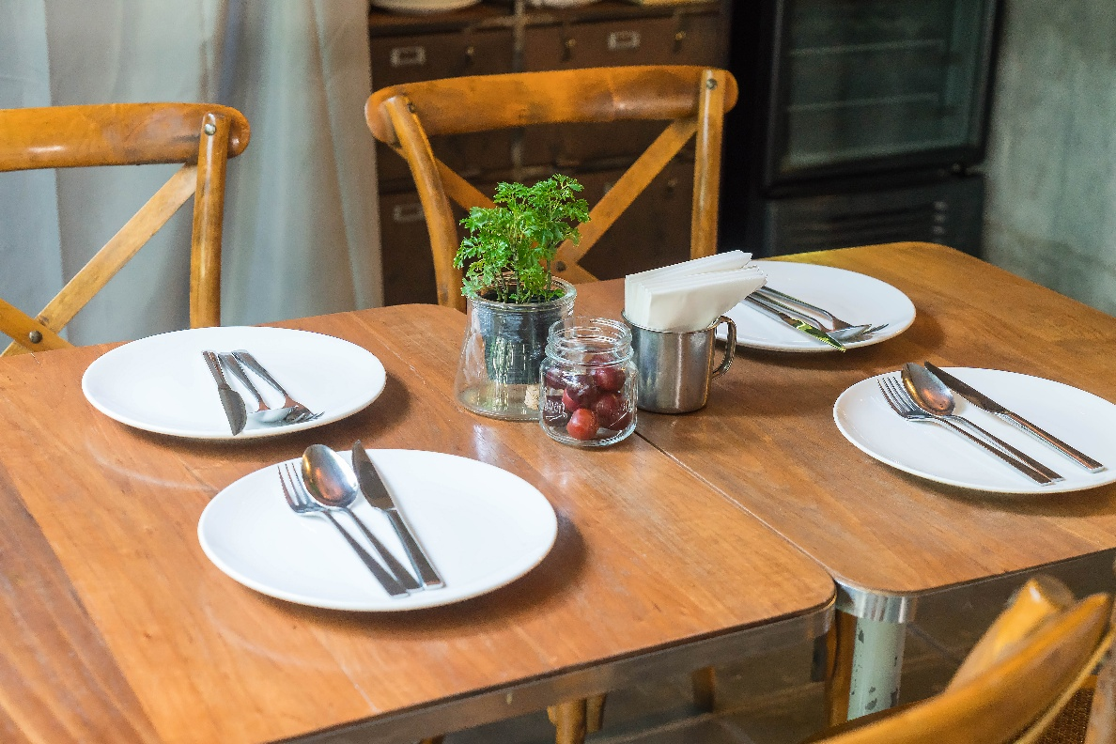
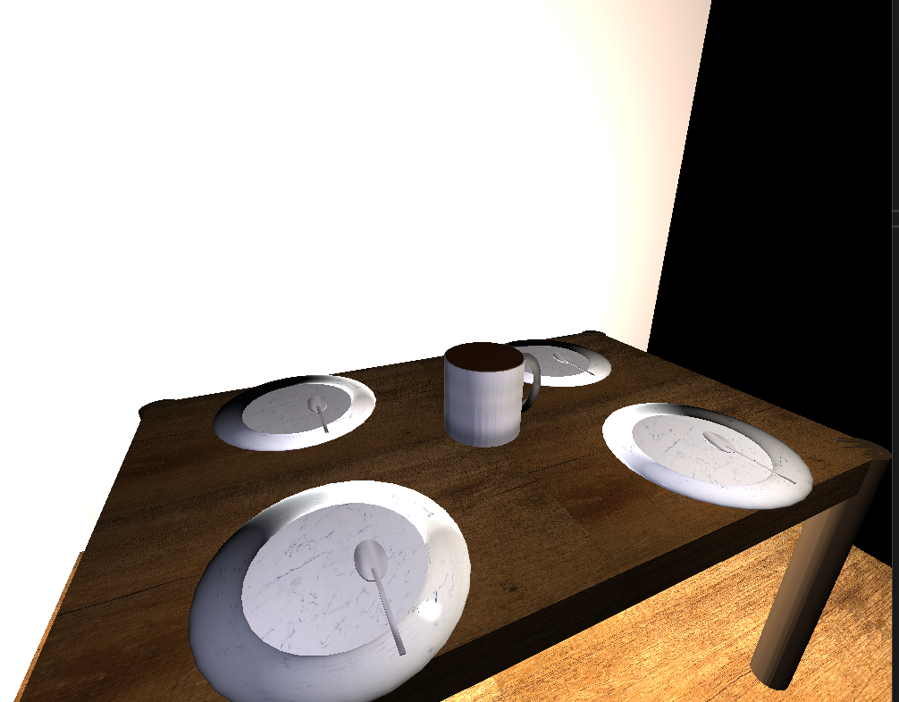

Development choices and scene justification
The 3D scene was designed as a still-life tabletop environment, including a table, plates, spoons, and a stainless-steel cup with coffee. From first glance you can tell that I’ve made a lot of scene compromises.
Object selection: The objects that I chose was to demonstrate a variety of light-material interactions, material textures, and compound objects.
Material Accuracy: I spent a lot of time differentiating materials and making sure that their shaders interacted with the lighting in a realistic manner. I manipulated specular reflection and other effects.
Geometric complexity: Functionality was programmed using transformations and compound shapes. A torus is attached to a cylinder to give the shape of a cup, and then a smaller cylinder was placed inside and vertically offset to give the impression that the cup is full of coffee.
User Navigation and Camera Control
The scene utilizes fly-through virtual camera controls. The user near unlimited control over the camera.
Mouselook: Moving the mouse cursor changes the pitch and yaw of the
Cardinal movement: WASD moves the camera forward, backwards, and pans left and right.
Ascending/Descending: Q and E moves ascends and descends the camera, respectively.
Roll: Z and X rolls the camera clockwise and counter-clockwise.
Speed control: Using scrollwheel increases the delta and therefore the speed of how quickly the camera moves with the control
Modular programming and functions
I made sure that the code was organized and maintainable.
Most shapes created all have similar functions called. For example, this is the code to draw the tabletop.
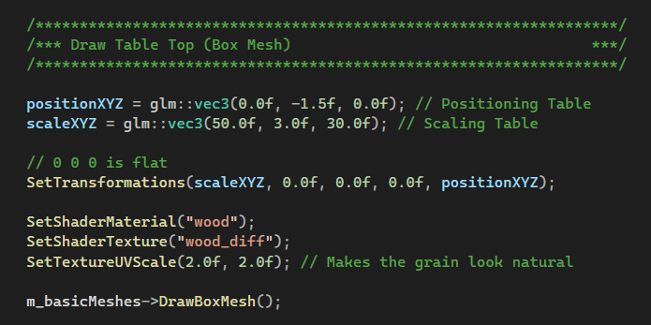
You can see that positionXYZ, scaleXYZ, SeTtransformations, SetShaderMaterial, SetTextureUVScale, SetShaderTexture, m_basicMeshes are components that are used to build a geometric shape. They determine where it is positioned, how large it is, whether it is rotated, what material it is wrapped in, how often or little it appears, and what shape the object is. To save space and reduce redundancy, some shapes that are reiterated are generated in loops that determine their position. An example of that is with the plates or the table legs.
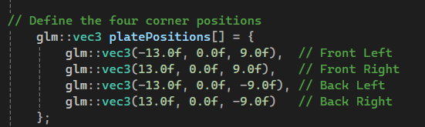
This is a container array that contains the data that is pulled from the following function that increments the index in order to implement the positions.
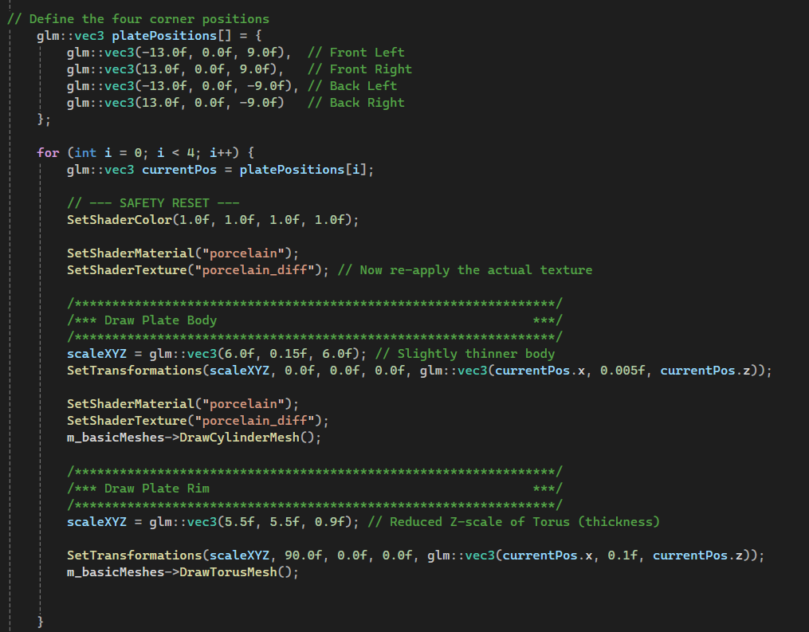
This saves both time and space by turning it into an iterative process rather than a manual one. If I need to adjust positioning, I just need to change the positions inside the array. Later, if I was doing something with mass iteration like keys on a keyboard, I could possibly just use an iterative double loop to increment at a fixed horizontal space for i and a fixed depth space for j. While it is not quite there, this is the foundation for a powerful tool, moving from hard-coded placement to algorithmic placement.
Final reflection
While I struggled and often had to compromise my original reference and creative vision, at the end of this term, I feel like I have learned a lot more about not just 3D design using code but also programming in general. I learned how modular functions can come together to form an object. The feeling of adding functionality to an already existing project made me feel like a software engineer working on a real project that has visible results, rather than smaller projects from scratch. I thought about the readability and scalability of code whether it is through iteration or algorithm. Overall, I feel like I learned a lot of practical skills.

